Spring 2016

WIRELESS NETWORKING

Project #3

Pashikanti Vishwak Adarsh (16224186)

kiran gavini ()

university of missouri –kansas city

**Wireless Networking**

Spring 2016

Project #3 – Due Thursday, May 5 by 11:59 p.m.

**Part 1 – Basic Scenarios**

Once you have chosen a project, go through the readme files for the scenarios, run the scenarios, and copy the results (usually graphs) that the readme files talk about into your report. Also show a screen print of the scenario. Some projects have provided more extensive discussions than other projects, so do the best you can within with what has been described.

**Results of Scenario : 1**

**11 n 40 Mhz with block ack**

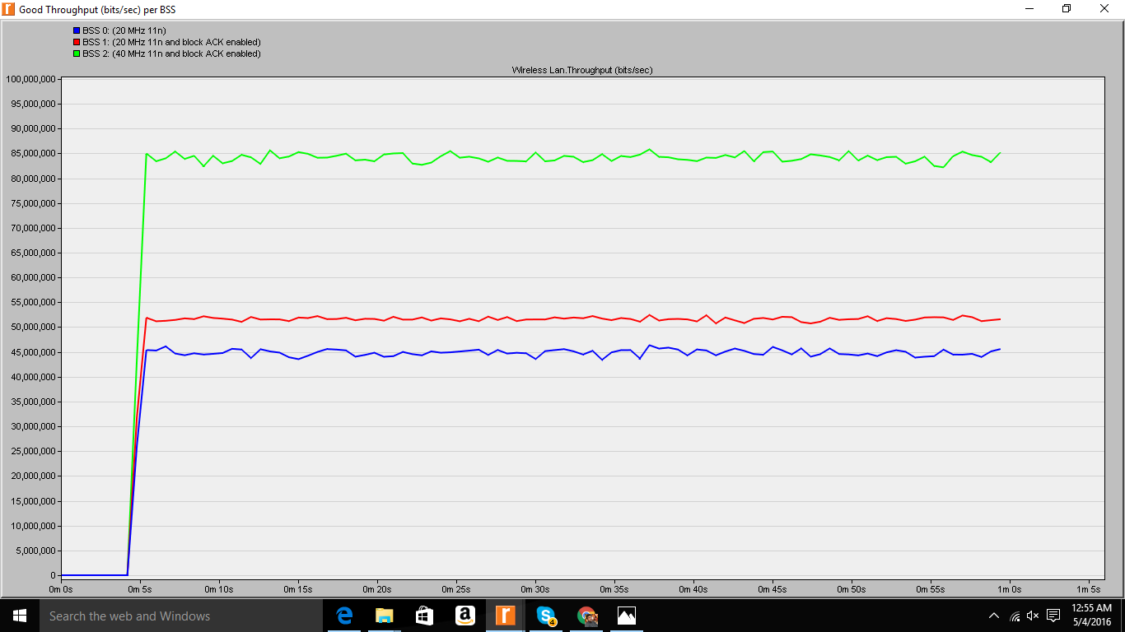

|  |  |
| --- | --- |
| Name of the BSS | Good throughput in bits/sec |
| BSS 0 | 44650958.84 |
| BSS 1 | 51409515.36 |
| BSS 2 | 83694938.99 |

**Results of Scenario : 2**

**FRAME AGGREGATION STUDY**

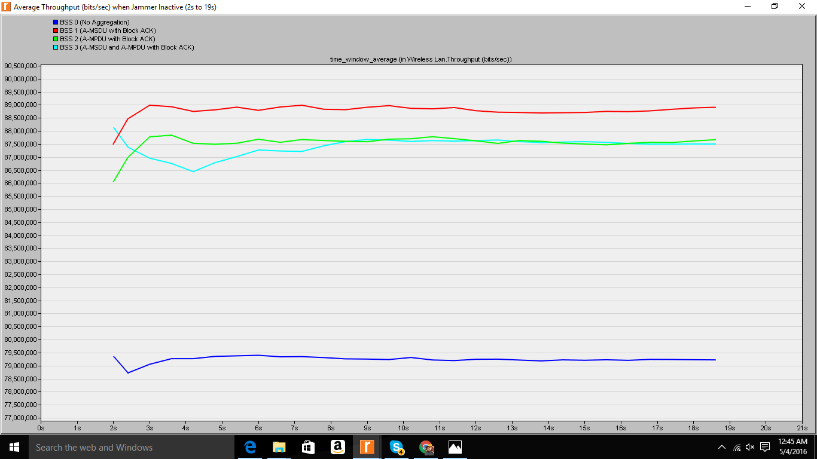

|  |  |
| --- | --- |
| Name of the BSS | AVERAGE THROUGHPUT (bps) |
| BSS 0 | 79237978.21 |
| BSS 1 | 88770867.37 |
| BSS 2 | 87537109.33 |
| BSS 3 | 87413562.78 |

**FRAME AGGREGATION STATISTICS**

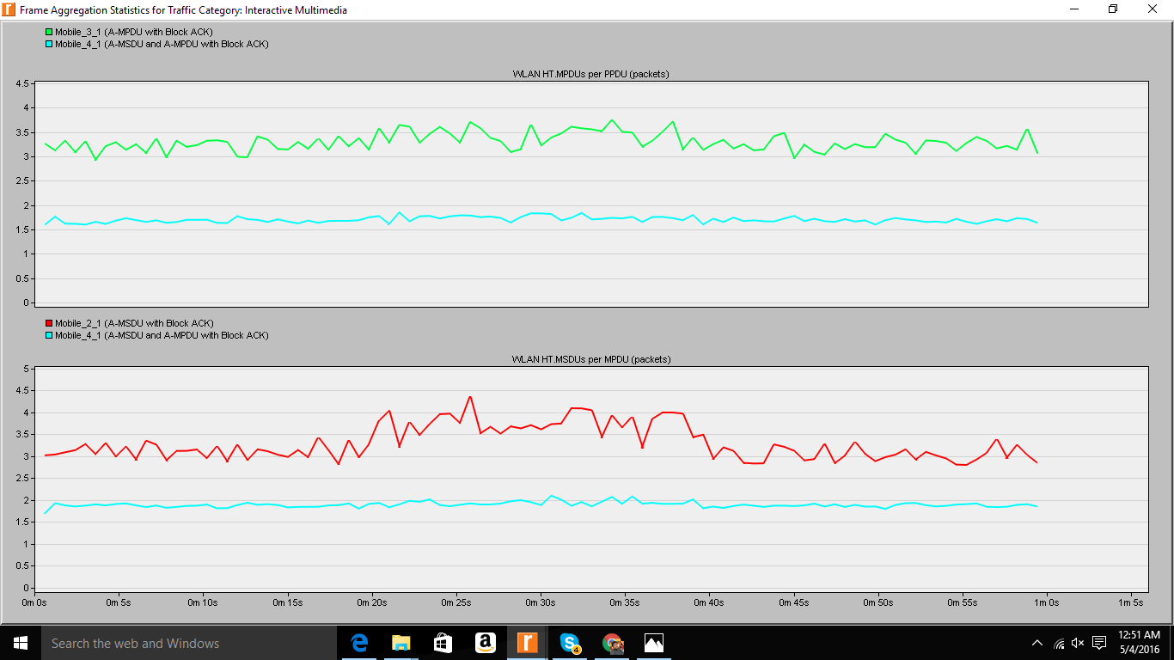

|  |  |
| --- | --- |
| NAME OF THE MOBILE NODE | AVERAGE NUMBER OF MPDUs per PPDU |
| Mobile _3_1 | 3.29943128 |
| Mobile _4_1 | 1.700228556 |

|  |  |
| --- | --- |
| NAME OF THE MOBILE NODE | AVERAGE NUMBER OF MSDUs per MPDU |
| Mobile _2_1 | 3.301922044 |
| Mobile _4_1 | 1.895480176 |

**Good throughput**

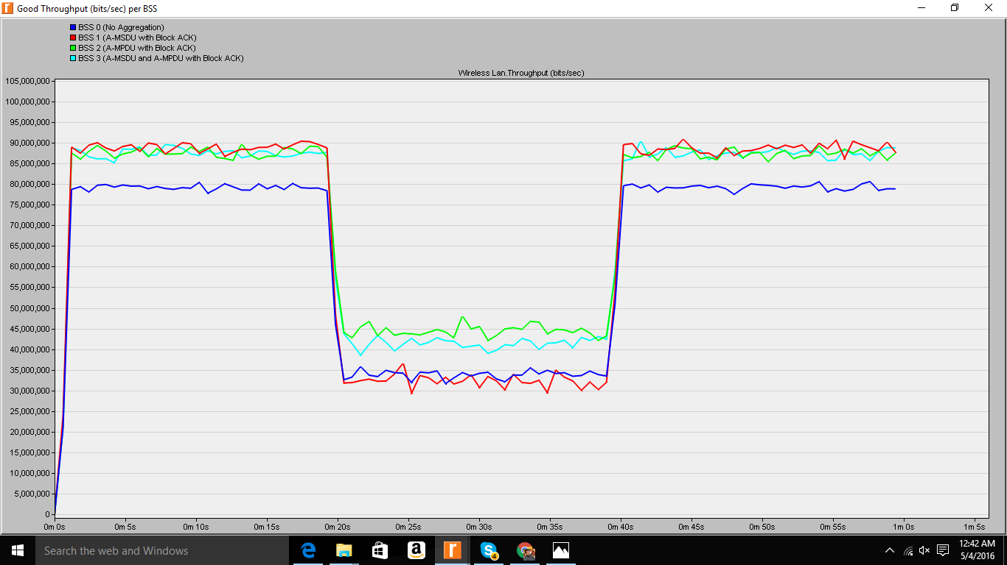

|  |  |
| --- | --- |
| Name of the BSS | AVERAGE THROUGHPUT (bps) |
| BSS 0 | 62700812.67 |
| BSS 1 | 68392248.4 |
| BSS 2 | 71596575.6 |
| BSS 3 | 70617946 |

**Throughput calculation when jammer is active**

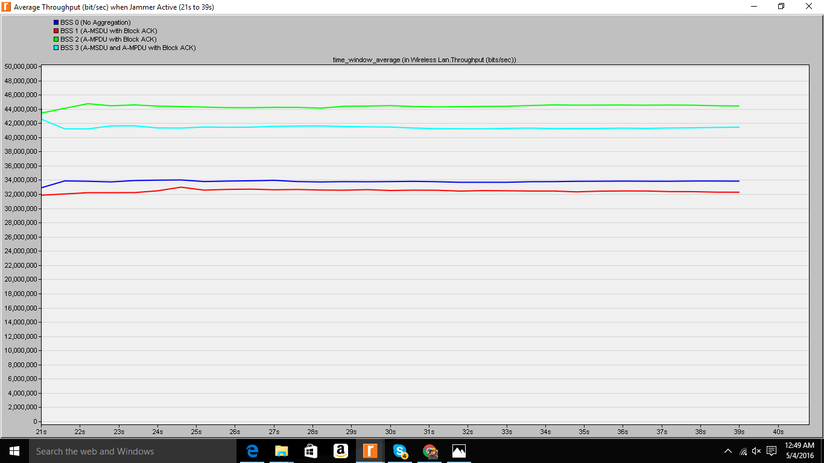

|  |  |
| --- | --- |
| Name of the BSS | AVERAGE THROUGHPUT (bps) |
| BSS 0 | 33738488 |
| BSS 1 | 32423451.79 |
| BSS 2 | 44351259.65 |
| BSS 3 | 41480030.91 |

**Results of Scenario : 3**

**PCF vs DCF**

**WIRELESS LAN WITH DELAY**

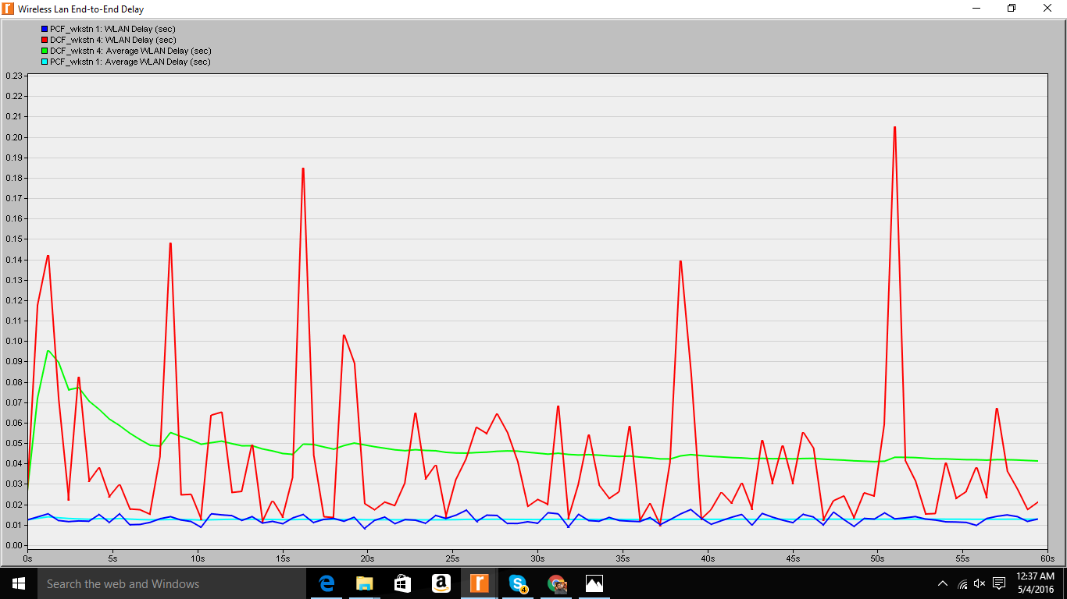

|  |  |
| --- | --- |
| Name of the WORKSTATION | Average Wireless Lan. Delay (sec) |
| PCF_ workstation 1 | 0.012718482 |
| DCF_ workstation 4 | 0.041272966 |
| DCF_ workstation 4 | 0.047571572 |
| PCF_ workstation 1 | 0.012666661 |

**Wireless LAN load**

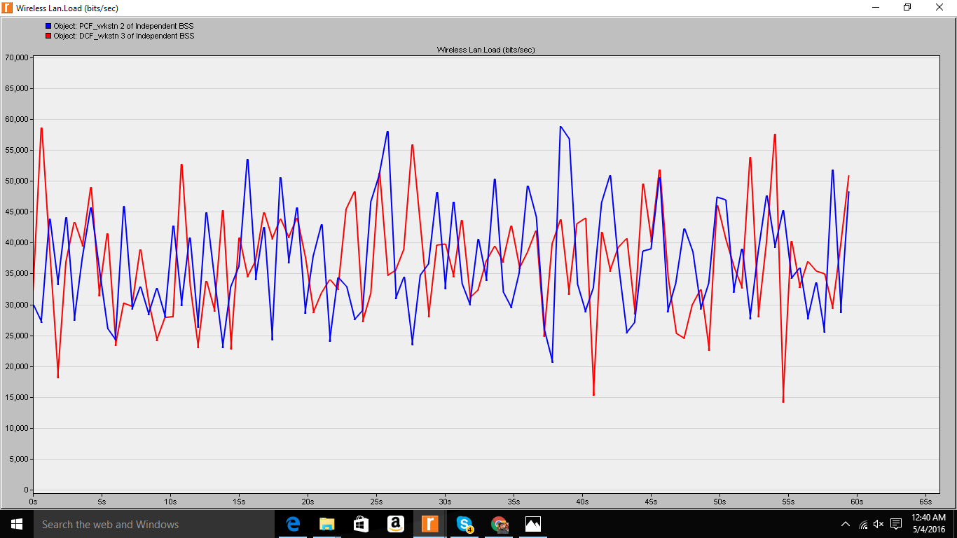

|  |  |
| --- | --- |
| Name of the WORKSTATION | AVERAGE wireless LAN load (bits/sec) |
| PCF_ workstation 2 | 36768.66667 |
| DCF_ workstation 3 | 36735.06667 |

**Wireless LAN retransmissions**

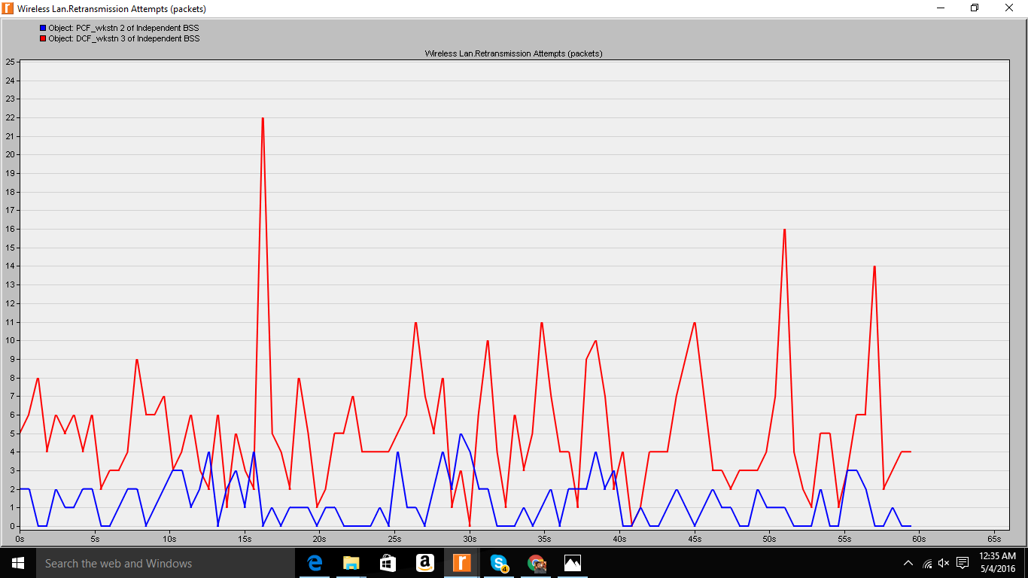

|  |  |
| --- | --- |
| Name of the WORKSTATION | AVERAGE Wireless Lan. Retransmission Attempts (packets) |
| PCF_ workstation 2 | 1.22 |
| DCF_ workstation 3 | 4.98 |

**Wireless LAN throughput**

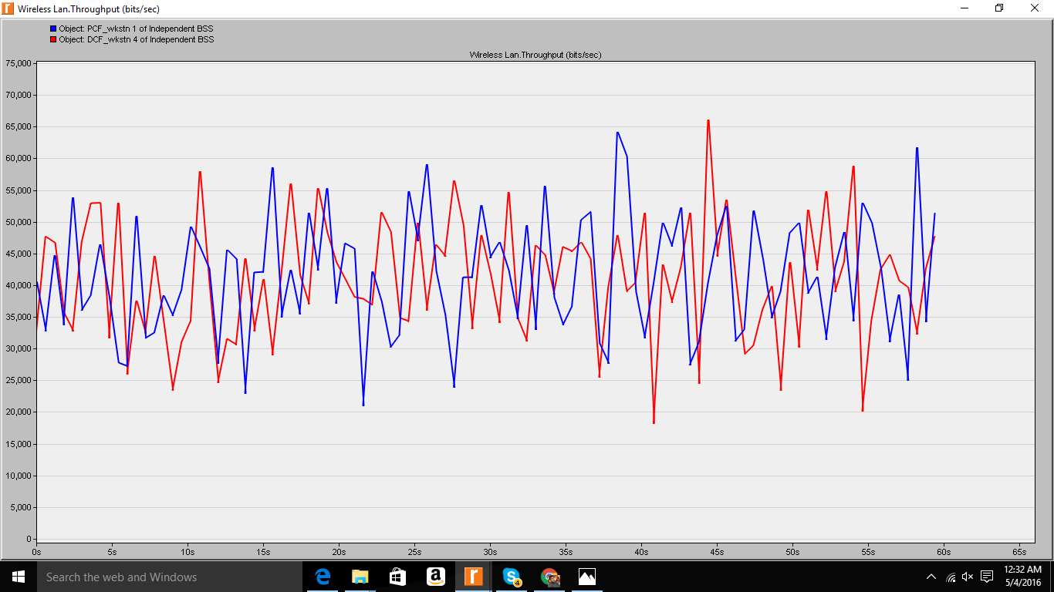

|  |  |
| --- | --- |
| Name of the WORKSTATION | AVERAGE Wireless Lan. Throughput (bits/sec) |
| PCF_ workstation 1 | 41372 |
| DCF_ workstation 4 | 40849.73333 |

**Results of Scenario : 4**

**Wireless LAN interface For client 2**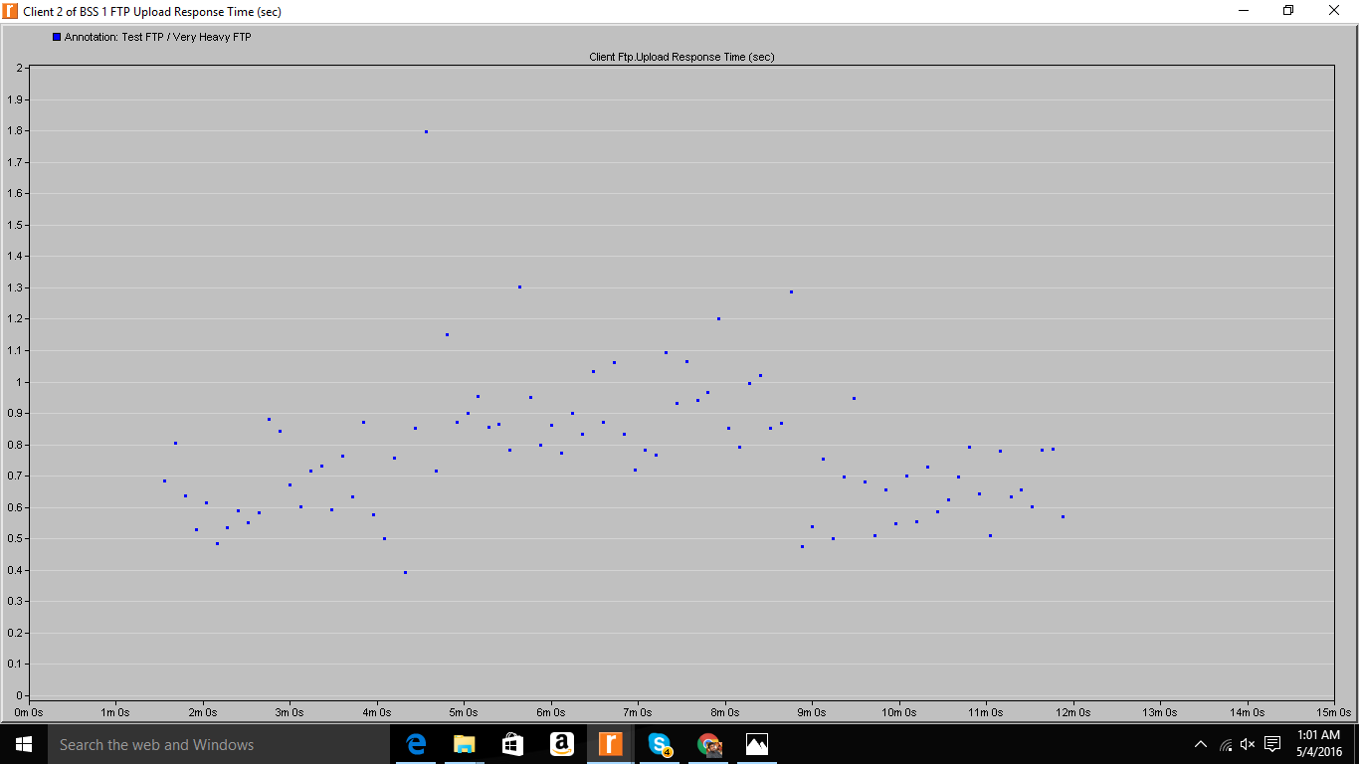

**Average WLAN Network.FTP Client 2.Client Ftp.Upload Response Time (sec) = 0.777104985**

**For client 7**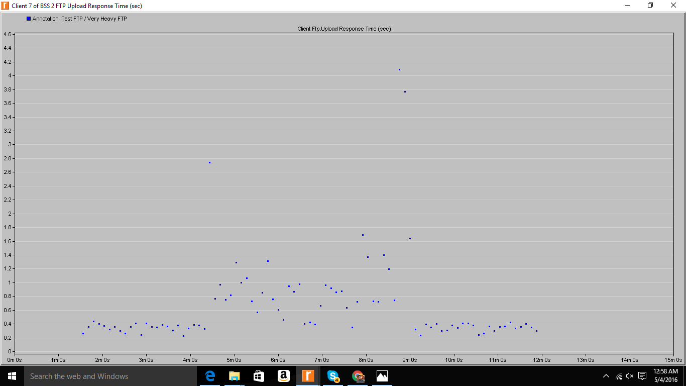

**Average WLAN Network.FTP Client 7.Client Ftp.Upload Response Time (sec) = 0.673320883**

**Global FTP response time**

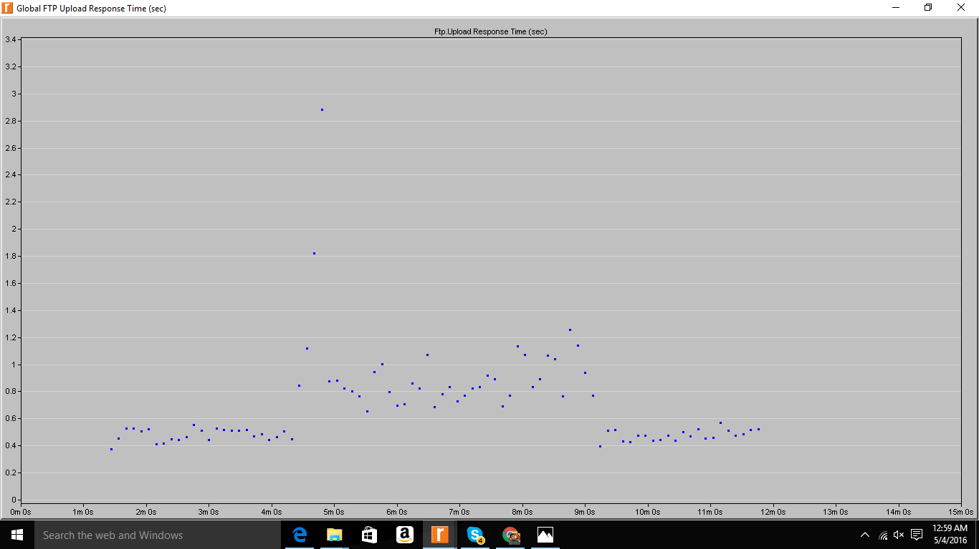

**Average Ftp. Upload Response Time (sec) = 0.696115405**

**Part 2 – Modified Scenarios**

With one of the same scenarios you used in Part 1, make some modifications to the scenario, rerun the scenario, and provide the results. Discuss the differences that you see in the results and provide a short discussion of why you think those results look as they do.

**Modified Results on changing the parameters in Scenario 4**

**Result 1 : On changing buffer size from 256000 to 64000 for**

**Client 2**

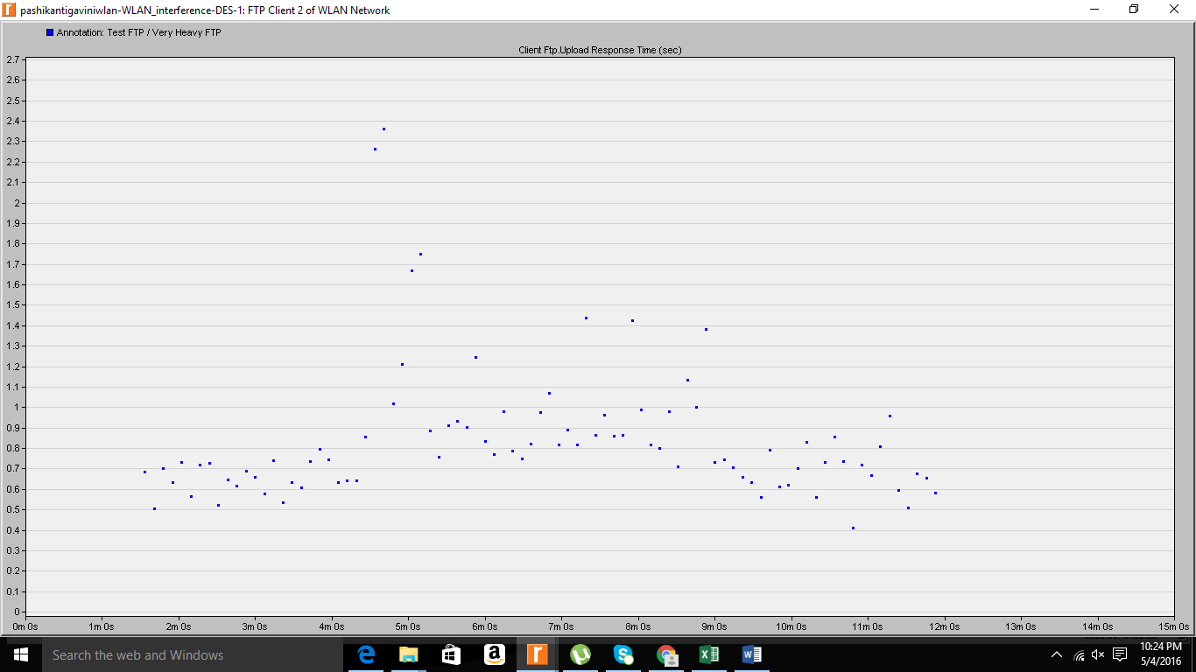 **Average WLAN Network. FTP Client 2.Client Ftp. Upload Response Time (sec) = 0.842085692**

**Client 7**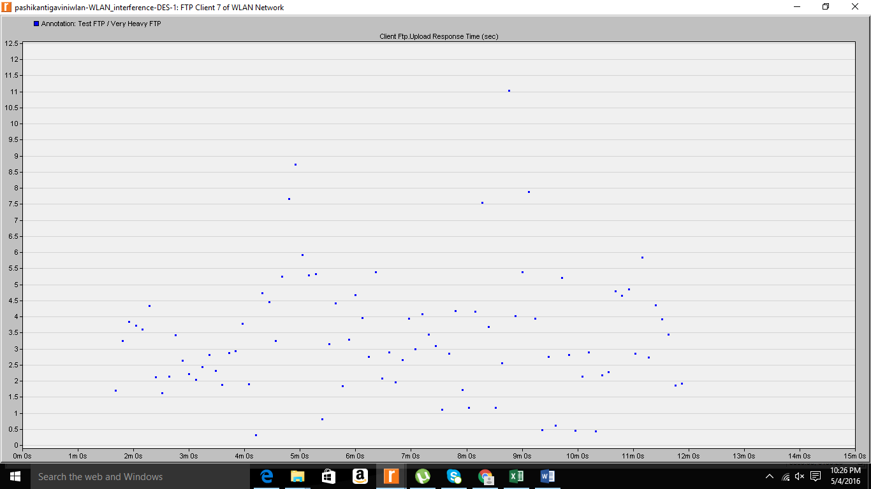

**Average WLAN Network. FTP Client 2.Client Ftp. Upload Response Time (sec) = 3.39400**

**Global throughput**

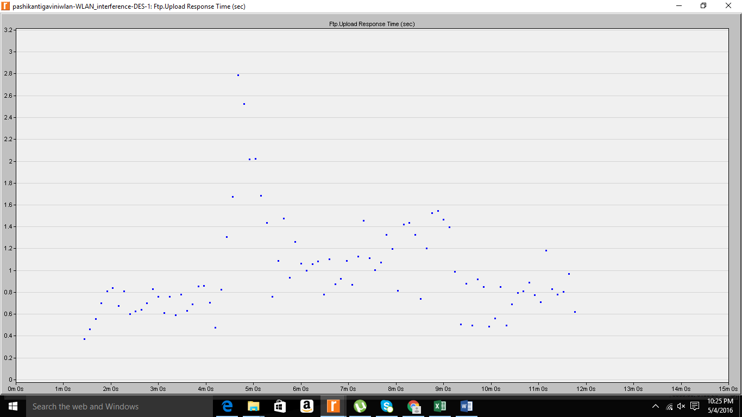

**Average WLAN Network Ftp. Upload Response Time (sec) = 0.989101429**

|  |  |  |  |
| --- | --- | --- | --- |
| Buffer size | Client 2 - Upload Response Time (sec) | Client 7 - Upload Response Time (sec) | Global - Upload Response Time (sec) |
| 256000 | 0.777104985 | 0.673320883 | 0.69611505 |
| 64000 | 0.842085692 | 3.39400 | 0.98910142 |

Reason for decrease increase in upload response time as buffer size is decreased:

When buffer size is less, the memory for storing will be less and stack doesn’t have enough space which increases complexity of computational ability and has to refresh memory after a certain operation is done. This increases the upload response time

**Result 2 : At critical distance**

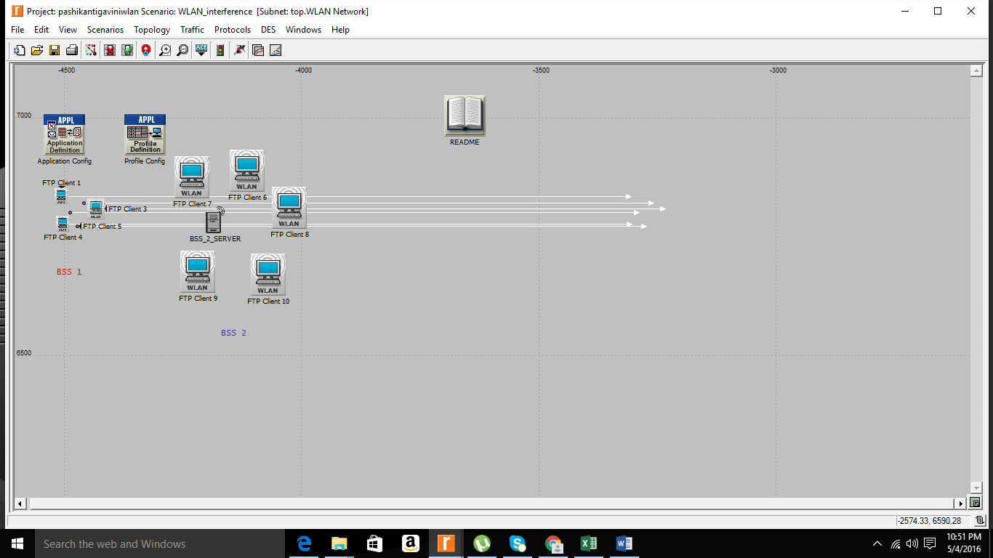

**For client 2**

**When the clients are in range with each other**



**At critical distance**

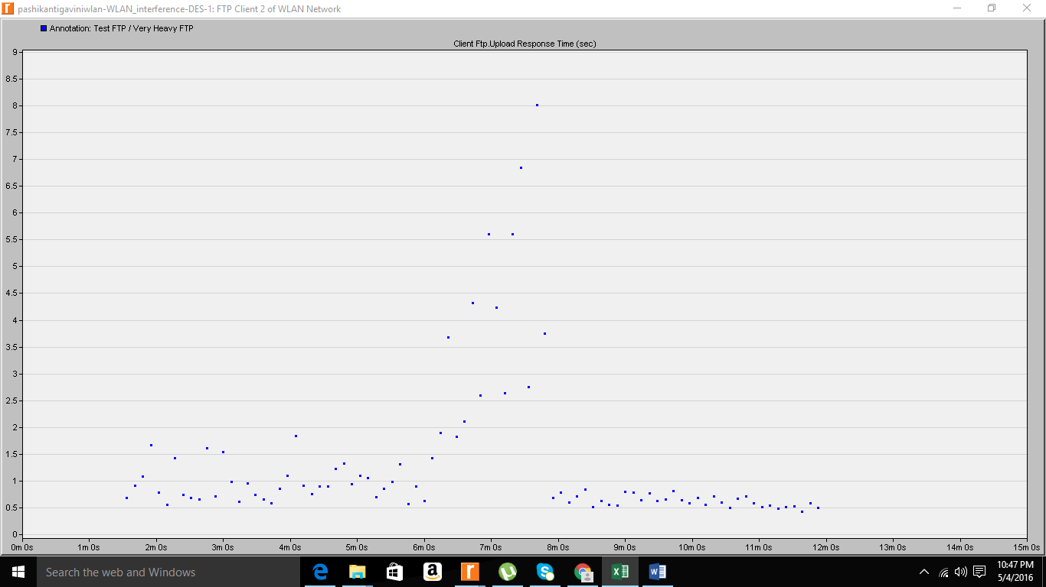

|  |  |
| --- | --- |
| Range | Average WLAN Network.FTP Client 2.Client Ftp.Upload Response Time (sec) |
| In range | **0.777104985** |
| Critical distance | **1.323102551** |

**For client 7**

**When in range**

**At critical distance**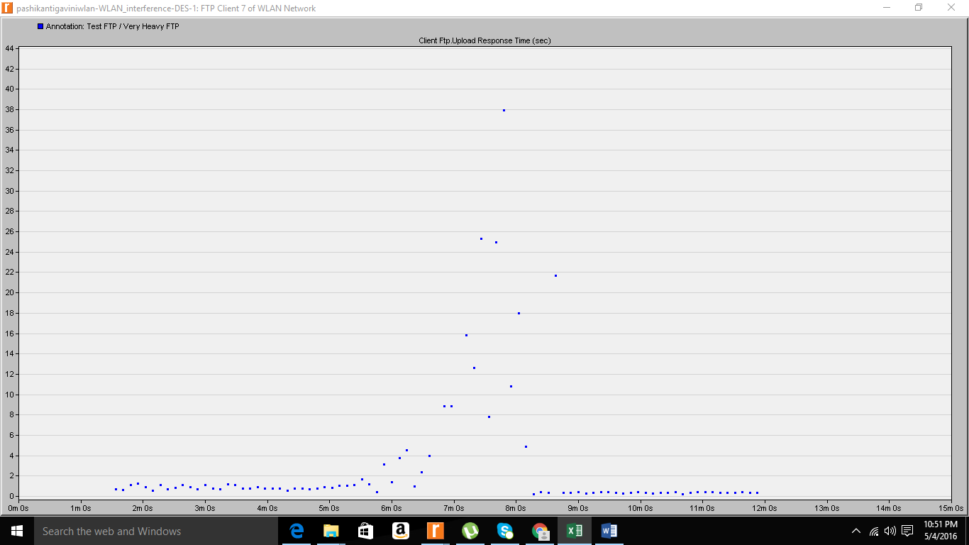

|  |  |
| --- | --- |
| Range | Average WLAN Network.FTP Client 7.Client Ftp.Upload Response Time (sec) |
| In range | **0.6733** |
| Critical distance | **3.0594** |

**Global throughput**

**In range**

**Critical distance**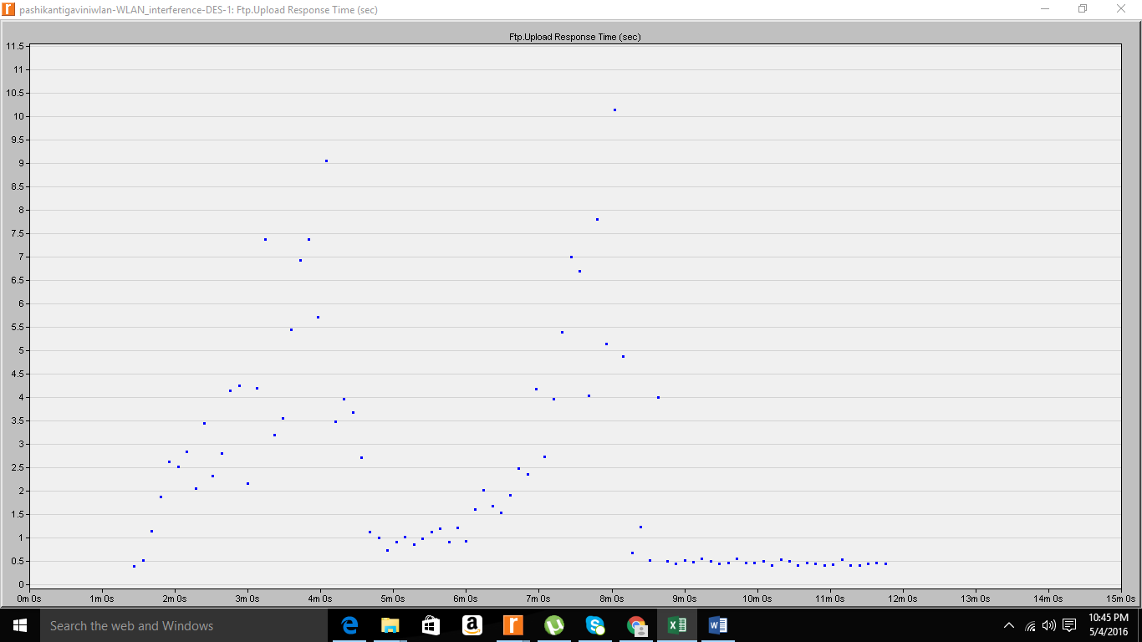

|  |  |
| --- | --- |
| Range | Average WLAN Network Ftp.Upload Response Time (sec) |
| In range | **0.6961** |
| Critical distance | **2.3666** |

**Result 3 :** Out of the range

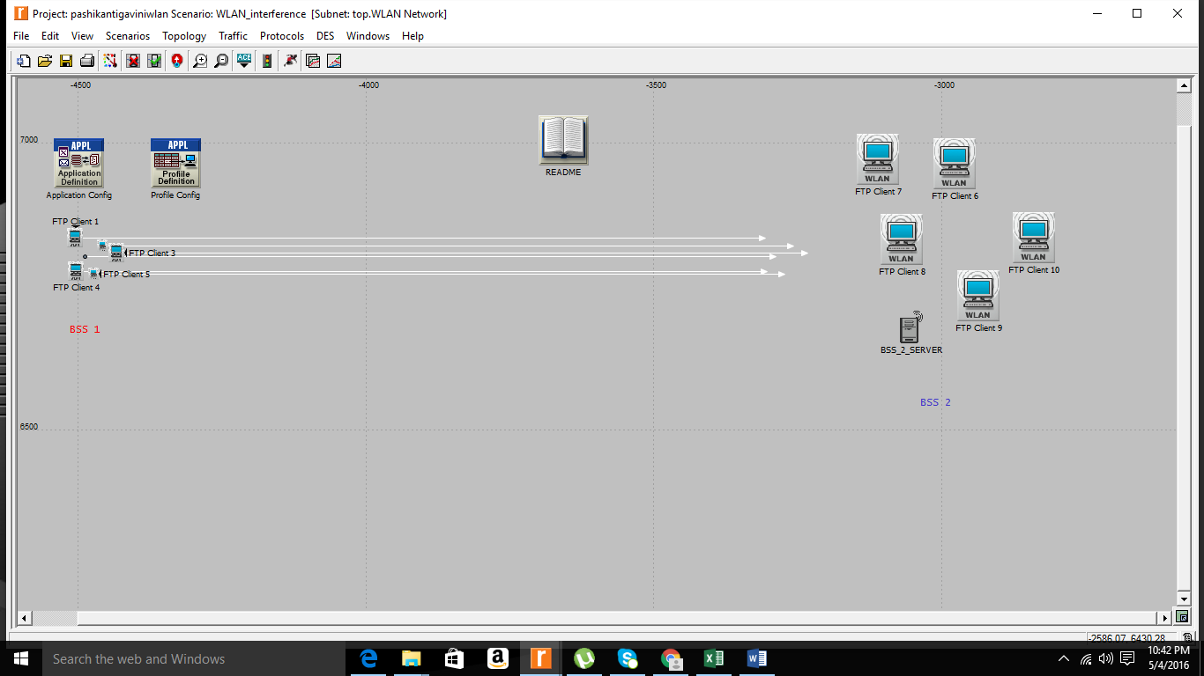

**Client 2**

In range 

Out of range

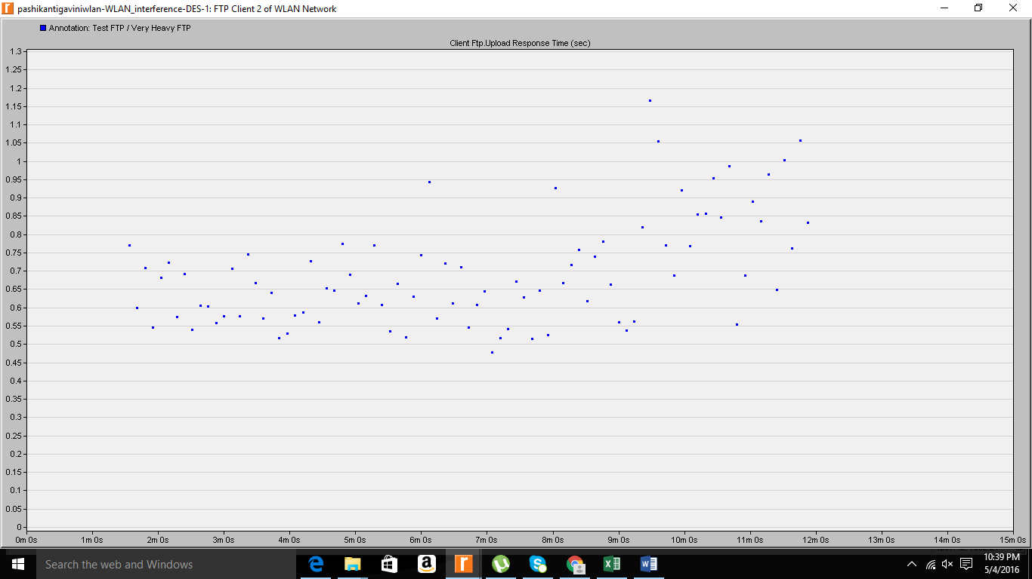

|  |  |
| --- | --- |
| Range | Average WLAN Network.FTP Client 2.Client Ftp.Upload Response Time (sec) |
| In range | **0.777104** |
| Out of range | **0.694362** |

Client 7 : In range



Out of range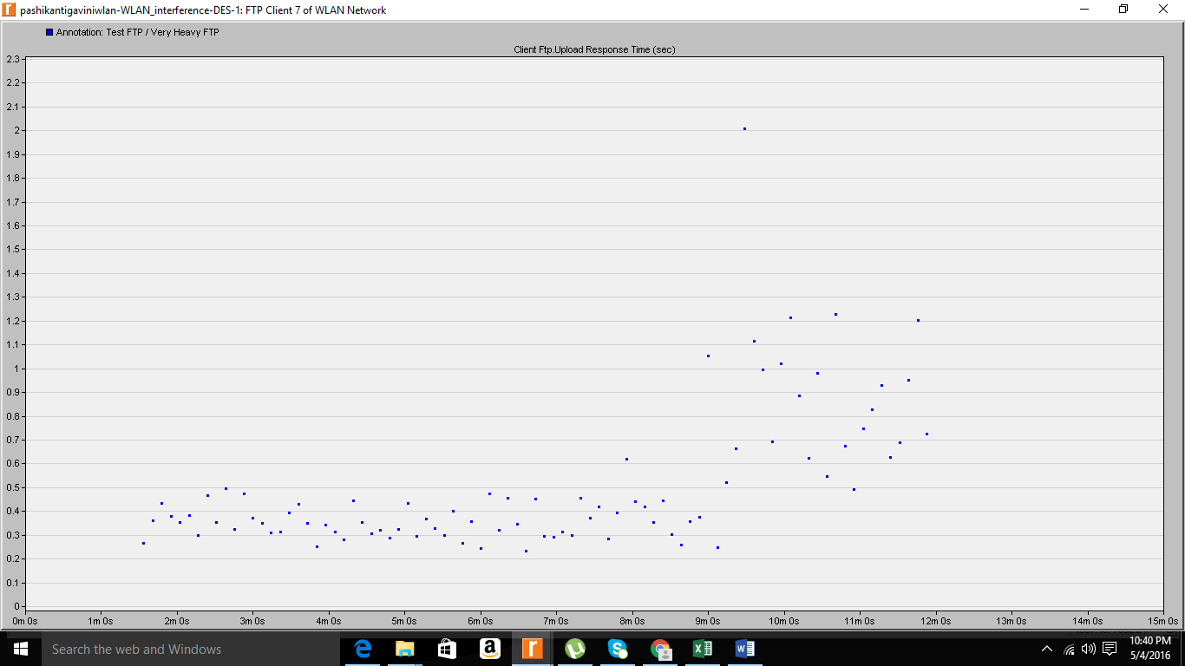

|  |  |
| --- | --- |
| Range | Average WLAN Network.FTP Client 7.Client Ftp.Upload Response Time (sec) |
| In range | **0.67332** |
| Out of range | **0.50539** |

Global throughput

In range 

Out of range

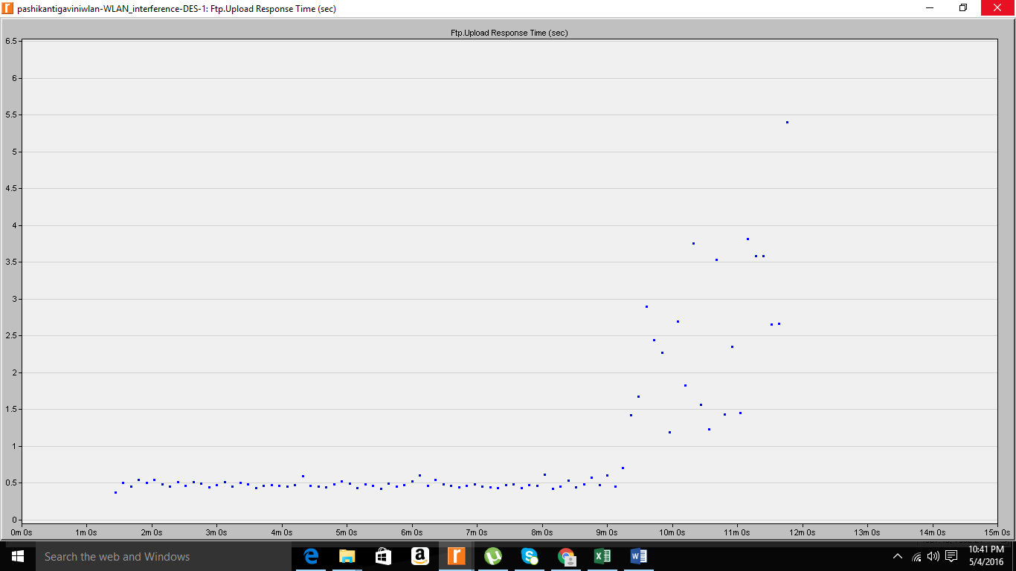

|  |  |
| --- | --- |
| Range | Average WLAN Network Ftp.Upload Response Time (sec) |
| In range | **0.6961** |
| Out of range | **0.9835** |

On comparing the max and min values for changes made in scenario 4

**For client 2**

|  |  |  |
| --- | --- | --- |
| Range | Minimum value | Maximum value |
| Given distance | 0.4 | 0.8 |
| At critical range | 0.52 | 8 |
| Out of range | 0.475 | 1.17 |

**For client 7**

|  |  |  |
| --- | --- | --- |
| Range | Minimum value | Maximum value |
| Given distance | 0.22 | 4.1 |
| At critical range | 0.4 | 38 |
| Out of range | 0.27 | 2 |

**Global**

|  |  |  |
| --- | --- | --- |
| Range | Minimum value | Maximum value |
| Given distance | 0.39 | 2.9 |
| At critical range | 0.45 | 10.2 |
| Out of range | 0.4 | 5.4 |